
MSIN0166 Data Engineering Group Assignment Report
Cyber Risk Data Engineering Pipeline: Evidence-Based Technical Report
Assessment: Group Assignment (Group Submission)
Word Count: 4000
Repository: https://github.com/ZoeLing0818/UCL-Data-Engineering-Group-Assignment
Team members listed in repository history: ZoeLing0818, Betty Lin, uleso26, pwang337-collab, chianyou, Steven19982004

Table of Content

Introduction
The cybersecurity landscape is increasingly shaped by the rapid disclosure of software vulnerabilities, yet remediation prioritisation remains difficult because technical severity does not consistently reflect real-world risk. CVSS provides a standardised measure of vulnerability severity, but high-severity vulnerabilities are not always exploited in practice, while some medium-severity issues become urgent once they are actively weaponised. As a result, organisations require a broader evidence base for prioritisation than severity scores alone.
Relevant cyber risk intelligence is fragmented across heterogeneous sources. NVD provides structured CVE metadata, CVSS/CWE information, and publication timelines; CISA KEV identifies vulnerabilities confirmed to be exploited in the wild; and EPSS estimates the probability of exploitation. Additional ecosystem feeds, such as GitHub Security Advisories and OSV, can further extend software supply-chain visibility. However, these datasets differ in format, schema, update frequency, and coverage. Without an engineered integration pipeline, combining them is inefficient, difficult to reproduce, and limited in analytical usability.
This project addresses that problem by building an end-to-end cyber-risk data pipeline that ingests multiple security feeds, standardises schemas, and integrates severity, exploitation evidence, and exploit probability into curated analytical datasets. The pipeline is designed not only to collect raw records, but also to transform them into a structured analytical environment that supports scalable querying and downstream risk analysis. In this way, the system enables investigation of disclosure trends, exploitation dynamics, and the divergence between CVSS severity and exploit likelihood, producing more actionable cyber-risk intelligence.
This report provides a technical evaluation of that pipeline based on repository implementation, command execution evidence, and generated output artefacts. Rather than relying on descriptive claims alone, it assesses whether the project successfully demonstrates source integration, transformation depth, warehouse loading, and analytical readiness, while also identifying any bounded operational gaps that remain before final submission.

Data Ingestion and Source Strategy

Core Vulnerability Feeds: Source Selection and Acquisition Design
The objective of this ingestion layer is not to accumulate more cybersecurity records, but to assemble a source portfolio in which each feed contributes a non-substitutable analytical signal for vulnerability prioritisation. In the implemented pipeline, NVD is the canonical CVE universe, CISA KEV provides exploitation-confirmation context, and EPSS provides probabilistic exploitability context. This combination supports practical triage because each CVE can be evaluated through severity, observed exploitation, and forecasted exploit likelihood.
Before fixing source scope, this section explicitly states what is not implemented in the current repository path. In the present codebase, additional advisory ecosystems (for example, GitHub Security Advisories or OSV-style branches) are not part of the production ingestion flow. The implemented branch focuses on NVD + KEV + EPSS so that identifier alignment, schema harmonisation, and validation effort remain controllable within assignment scope. cvelistV5 is ingested as an enrichment source for CVE record context, but it is not used as a primary scoring signal in the priority mart. For this deliverable, this source set is the most reproducible high-value core path.
Acquisition is implemented through dedicated ingestion scripts rather than manual downloads. The NVD feed is collected using UTC time-window filtering and paginated retrieval, then exported as both raw and normalised outputs. The KEV feed is collected as an authoritative structured feed with explicit request-error handling and timestamped completion records. The EPSS feed is collected through offset-based pagination and persisted as both latest and timestamped snapshots. This separation by source type reflects feed heterogeneity and improves debugging clarity.
Measured outputs from the validated run confirm operational completeness for the three core feeds: NVD contributed 5,133 vulnerability records, CISA KEV contributed 1,529 known-exploited records, and EPSS contributed 318,105 scored rows. The primary integrated table remained anchored to NVD coverage and produced 5,133 final CVE rows. cvelistV5 is treated as the fourth source branch in this section, but it enters the pipeline through a separate enrichment-table layer rather than being directly merged into the primary integrated table. This design improves discrimination in prioritisation because a single CVE can be evaluated through severity, confirmed exploitation, and exploit probability rather than severity alone.
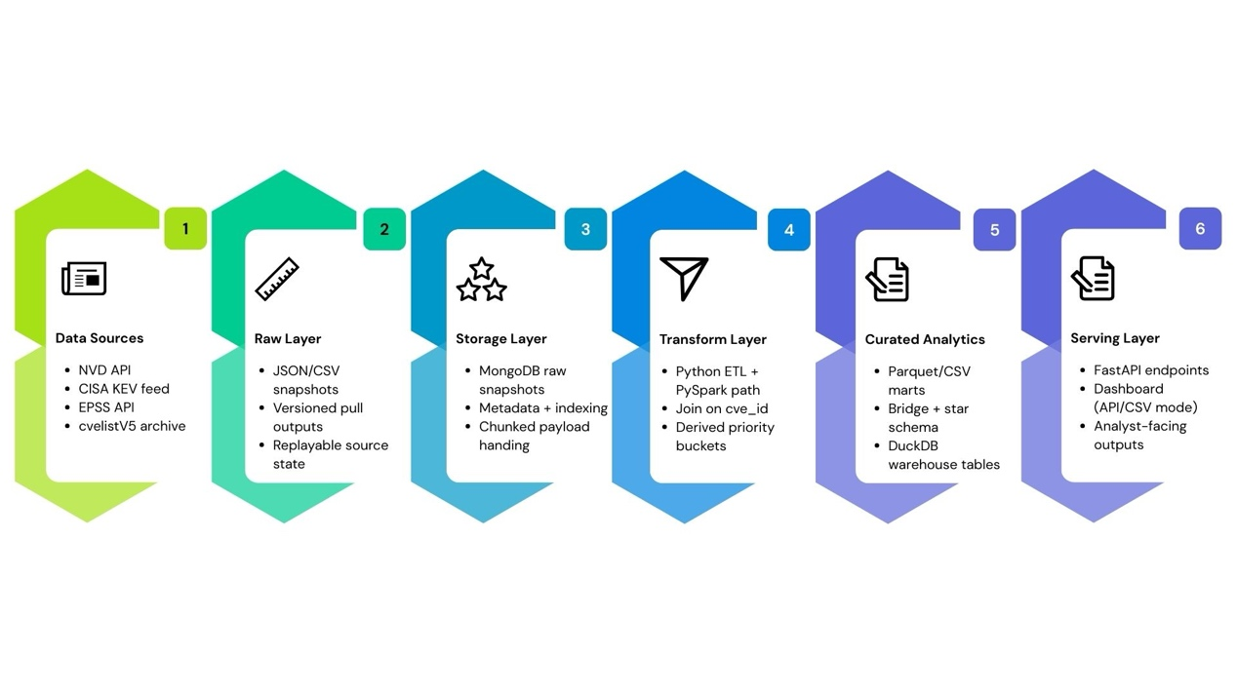
Figure 2.1 End-to-end cyber-risk data engineering architecture)
To avoid ambiguity between source coverage and schema feature columns, the four-source inventory is summarised first, followed by field-level schema contracts.
Table 1: Source inventory and pipeline status (four-source scope)
Source | Measured Count | Role in Pipeline | Current Status
NVD | 5,133 | Canonical CVE base universe | Ingested and integrated in curated mart
CISA KEV | 1,529 | Known exploited signal enrichment | Ingested and integrated in curated mart
EPSS | 318,105 | Exploit probability enrichment | Ingested and integrated in curated mart
cvelistV5 | 336,661 (CVE-*.json) | Record-level enrichment branch | Acquisition succeeded; enrichment parser currently fails on non-record files
Table 3.2 Source inventory and pipeline status (four-source scope).

2.2 Ingestion-to-Curation Data Contract and Storage Rationale
In this project, ingestion is treated as the first stage of schema control. The key design rule is that integration-ready fields are normalised early, not deferred to late-stage notebooks. The canonical join key is cve_id, with NVD as base grain and KEV/EPSS attached as enrichments. This preserves broad coverage while adding risk signals without changing record identity. Using NVD as the canonical base also preserves a stable CVE-level grain, allowing narrower feeds to enrich rather than redefine the analytical population.
The primary curated output captures core analytical features required by downstream warehouse queries and dashboard endpoints. The table below summarises major columns retained in the implemented pipeline.
Feature Name | Type (Pipeline Contract) | Description
cve_id | String | Canonical CVE identifier used as integration key
published | Timestamp/String (ISO-like) | Publication timestamp from NVD feed
last_modified | Timestamp/String (ISO-like) | Last modification timestamp from NVD feed
cvss_base_score | Double | Numerical CVSS base score extracted with version fallback logic
cvss_severity | String | Severity label (LOW/MEDIUM/HIGH/CRITICAL/UNKNOWN)
cwe_id | String | Primary CWE identifier when available
vendor | String | Vendor parsed from CPE criteria when available
product | String | Product parsed from CPE criteria when available
in_kev | Boolean | Whether CVE is present in CISA KEV feed
kev_date_added | Date/String | Date the CVE was added to KEV catalog
epss_score | Double | Exploit prediction score from EPSS feed
epss_percentile | Double | EPSS percentile rank
priority_bucket | String | Derived risk bucket from explicit rule logic
Table 3.3 Core columns in the primary integrated vulnerability table.
Beyond the primary integrated table, the pipeline materialises product-dimension, CVE-product bridge, and star-schema risk tables. This modelling decision is important for data engineering assessment because it demonstrates handling of many-to-many product relationships and dimensional analytics readiness, rather than relying on one flat extract.
Feature Name | Type (pipeline contract) | Description
cve_id | String | CVE key in relationship table
product_key | String (CPE URI) | Unique product identifier derived from CPE criteria
is_vulnerable | Boolean | Whether CPE match marks vulnerable=true
version_start_including/excluding | String | Lower version boundary from CPE match metadata
version_end_including/excluding | String | Upper version boundary from CPE match metadata
match_criteria_id | String | Source match criteria ID for lineage and auditability
node_operator | String | Logical operator from NVD configuration node
node_negate | Boolean | Negation flag from NVD configuration node
Table 3.4 Key columns in the CVE-product bridge and related product-impact contract
Storage choices are also intentional. Raw snapshots persisted as JSON/CSV artifacts for replay ability and auditability, and optional MongoDB raw loading supports document-native storage plus chunk handling for large payloads. Curated outputs are exported as CSV/Parquet for warehouse loading, and DuckDB is used as a lightweight analytical serving layer. This layered design reduces repeated external API dependency during analysis cycles, supports team reproducibility, and is more robust than notebook-only transient processing because each stage leaves inspectable artifacts and can be rerun independently.

2.3 cvelistV5 Acquisition, Enrichment Path, and Boundary Conditions
The cvelistV5 branch is used to enrich CVE-level records with container metadata, references, and problem-type details. The acquisition step downloads and extracts the official archive into the raw snapshot area, after which the enrichment parser materialises dedicated tables for CVE records, references, problem types, and containers. These outputs are then consumed by downstream schema steps (for example, CWE dimension enrichment).
During earlier validation, enrichment initially failed because the parser assumed every JSON file in the snapshot was a CVE-record dictionary, while some files had non-record list structures. This issue was resolved by adding parser guards that skip non-CVE JSON files and continue processing valid record files. As a result, the cvelist enrichment path now executes successfully and remains fully compatible with the core NVD-KEV-EPSS integration flow.
The implemented cvelist enrichment contract is summarised below.
Feature Name | Type (pipeline contract) | Description
dim_cve_records_latest.cve_id | String | CVE identifier in cvelist enrichment layer
state / date_reserved / date_published / date_updated | String (Date-like) | Lifecycle fields from cvelist metadata
assigner_org_id / assigner_short_name | String | Assigner metadata for governance context
bridge_cve_references_latest.url | String | External advisory/reference URL linked to CVE container
bridge_cve_problem_types_latest.cwe_id | String | CWE mapping extracted from container problemTypes
fact_cve_containers_latest.container_name | String | Container identity (cna, adp_*)
fact_cve_containers_latest.descriptions_en | String | English description text extracted from containers
Table 4. Intended schema contract for cvelistV5 enrichment outputs.

2.4 Scalability and Automation Considerations
The current ingestion architecture is batch-oriented but extensible. Core scripts are parameterised (time window, pagination limits, output directories), which supports repeatable runs and future scheduling integration. A practical next step is to wrap ingestion and transformation with orchestration (for example cron, Airflow, or GitHub Actions) and add source-specific schema guards before merge. For source expansion, staged onboarding is recommended: add one source at a time, validate key compatibility and null impacts, and then integrate into the canonical mart.

2.5 Limitations
Key limitations identified in the current implementation are:
- Source cadence mismatch: NVD, KEV, and EPSS update at different rhythms, so enrichment freshness is not perfectly synchronized in every run.
- Identifier attachment boundaries: some enrichment fields remain null when source-side mappings are missing or not parsable.
- cvelist parser robustness: mixed file types in repository snapshots require additional type guards before full enrichment claims can be made.
- Environment reproducibility: full rerun consistency depends on declared dependencies and interpreter consistency.
Overall, this section shows that ingestion in this project is implementation-grounded and evidence-backed: source scope is explicit, acquisition is operationalised through script contracts, schema expectations are stated, and limitations are bounded with reproducible evidence rather than narrative assumptions.

3 Storage, Schema Design, and Transformation

Layered Storage Logic and Lineage Controls
Storage was organised in layers rather than as one continuous path from extraction to dashboard output. Raw files were retained first, intermediate outputs were staged separately, and curated datasets were then written in CSV and Parquet. Once multiple sources with different structures began to enter the same pipeline, this separation became necessary. The original payload could still be checked directly, while Apache Spark (PySpark) was used as the primary compute engine for intermediate parsing and transformation tasks at scale. This kept the staged processing layer separate from the raw source state and reduced the extent to which source-level irregularities were carried forward into curated outputs.
In the raw layer, MongoDB was used as a persistence store rather than as the final analytical engine. The source data is semi-structured and nested in places, particularly in the NVD branch, so early conversion into a fully relational structure would have reduced flexibility too quickly. Source payloads were therefore stored together with metadata such as “source_name”, “snapshot_date”, “ingested_at”, “file_name”, and “file_path”. Retrieval and uniqueness indexes were also created. Oversized payloads were handled through chunk collections where needed, with list-heavy content split into related “_chunks” collections instead of being forced into one large document.
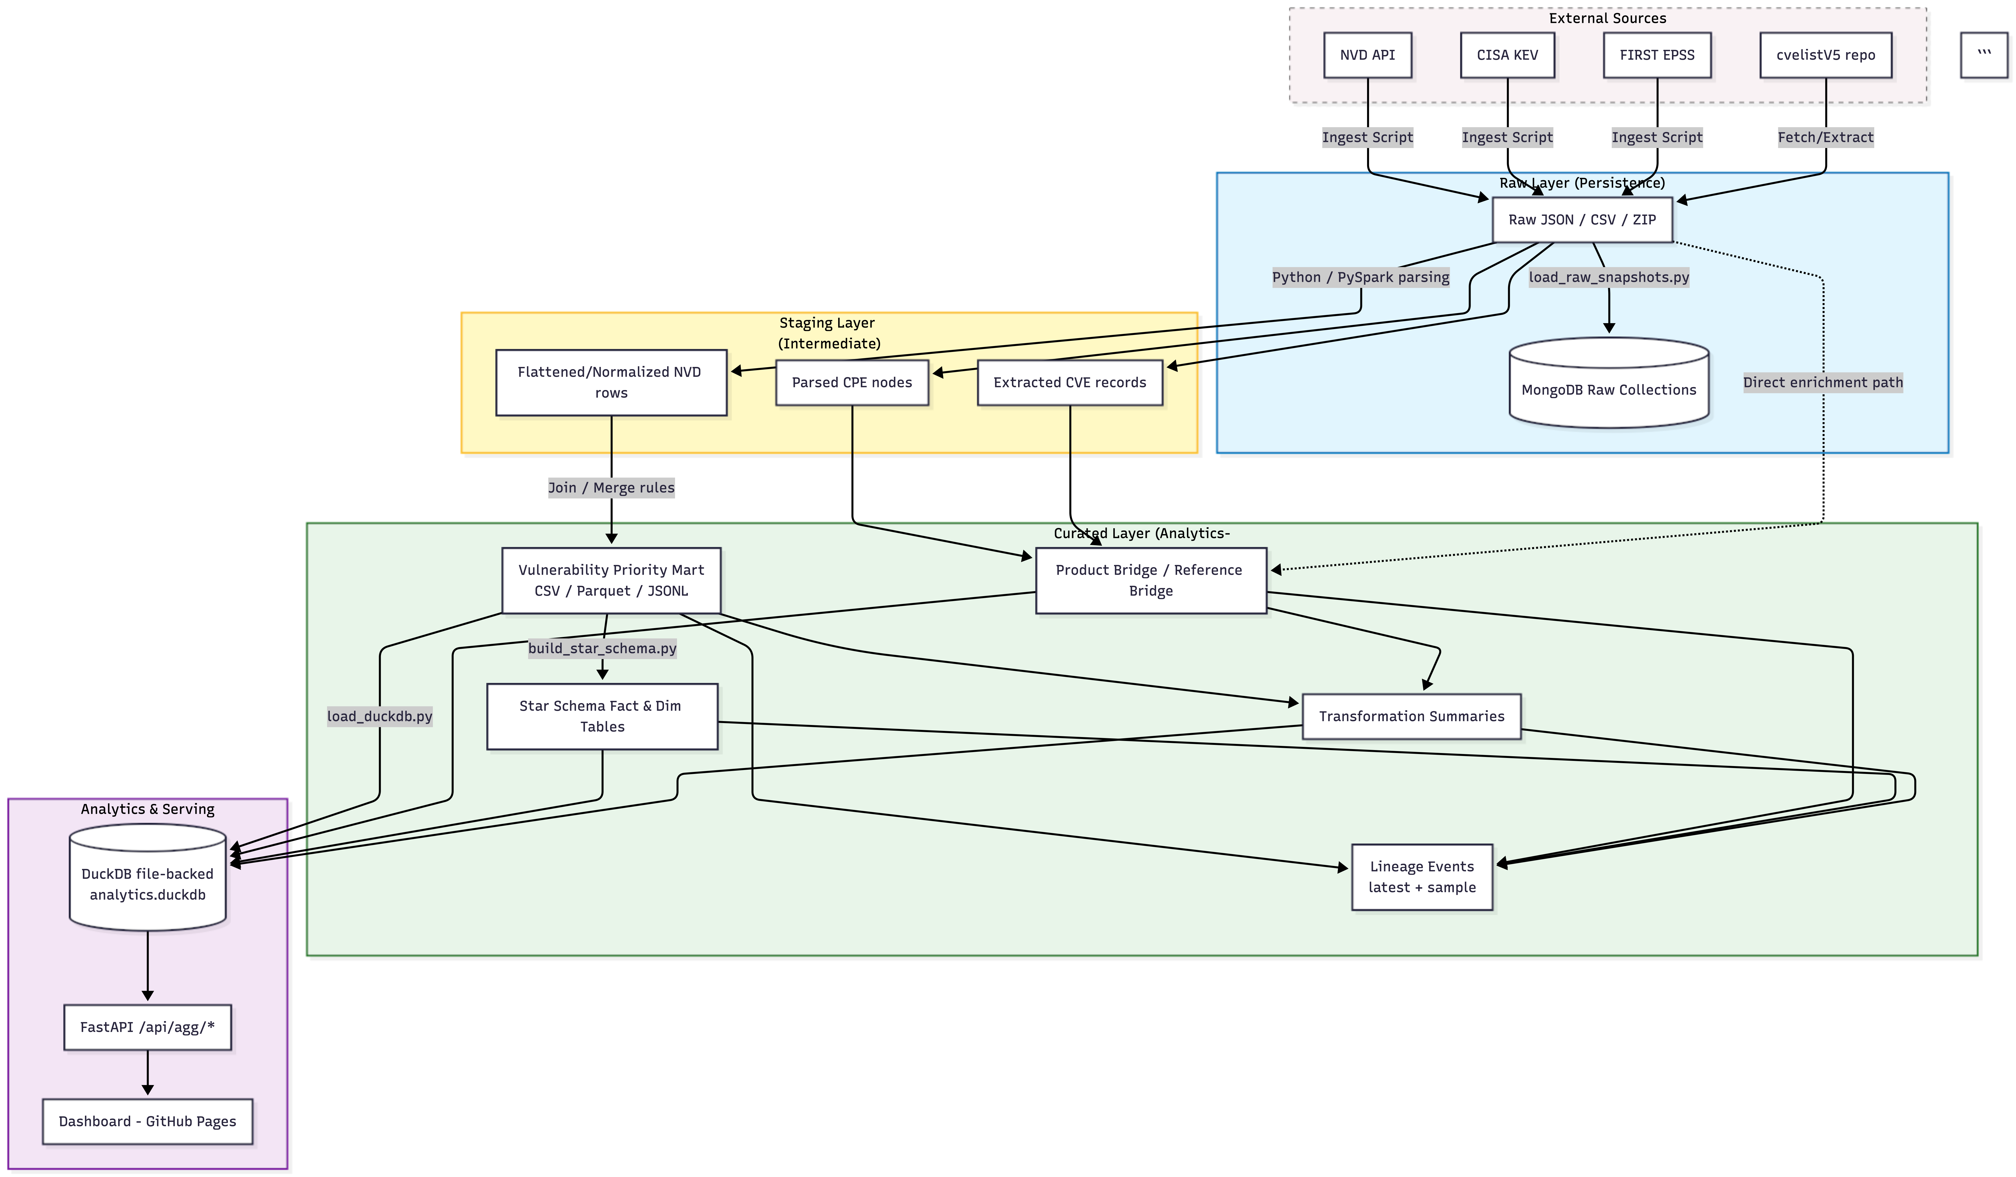
Figure 3.1: Layered storage and transformation boundary flow chart
  - Integration Rules and Priority Logic
The integrated data mart was built by retaining NVD as the base table and joining KEV and EPSS through “cve_id”. A stable row grain followed from that decision. One NVD CVE remained one row after enrichment, while narrower sources were attached to the record instead of redefining the population underneath it. KEV or EPSS could not have played the same role because neither source was broad enough to define the full vulnerability set.
Derived fields were added during the same transformation stage. These included “in_kev”, KEV dates, EPSS score, EPSS percentile, and “priority_bucket”. Classification logic was encoded directly in the transformation rather than being left to later dashboard interpretation. A record was assigned to “critical” if it was KEV-flagged, or if EPSS was at least 0.9, or if CVSS was at least 9.0. Lower thresholds were then used for “high”, “medium”, and “low”. As a result, severity, exploitation evidence, and exploitation probability were already assembled in one record before analysis began.
Coherence at this stage mattered as much as completion. A joined table is not automatically a reliable mart. Once key inflation or field drift appears, downstream ranking becomes difficult to trust. In this case, the structure remained interpretable. KEV enrichment was much narrower than EPSS enrichment, which is consistent with the nature of the two sources.

Bridge and Star-Schema
The integrated mart was sufficient for record-level prioritisation, but product relationships introduced a different modelling problem. A single CVE can affect multiple products, and a product can appear across many CVEs. A wide-table design would have made that relationship harder to preserve once repeated product fields and version ranges started to accumulate. Product extraction from NVD CPE criteria was therefore written into “dim_products_latest” and “bridge_cve_products_latest”, with criteria and version-range information retained alongside the relationship.
The star schema extends the same logic. “dim_date”, “dim_priority”, “dim_severity”, and “dim_cwe” were separated from “fact_vulnerability_risk”, and product exposure counts were derived from the bridge layer. Two analytical shapes were therefore available. Direct vulnerability ranking remained easier in the mart, while repeated reporting and dimensional slicing became easier in the star schema.
  - Transformation Summary Marts and Execution Status
Summary marts were also produced from the curated outputs. These included daily new CVE counts, CVSS severity distributions, KEV hit rates by severity, EPSS high-risk distributions by vendor and product, and aggregated CWE-vendor-product views. The high-risk EPSS threshold was fixed in code at 0.7, so the summary outputs followed the same implemented rules as the rest of the transformation layer.
A separate analytical layer was then provided through DuckDB. The choice fits the project reasonably well because the curated outputs were already written in analysis-friendly formats, especially Parquet, and the querying need was local rather than infrastructure-heavy.
Most of the main transformation path completed successfully. The vulnerability mart was built, bridge outputs were generated, star-schema tables were produced, summary marts were written, and the DuckDB load succeeded. The remaining incomplete branch was the cvelist enrichment path. Its failure did not interrupt the main modelling flow built on NVD, KEV, and EPSS, so the core analytical outputs remained available.
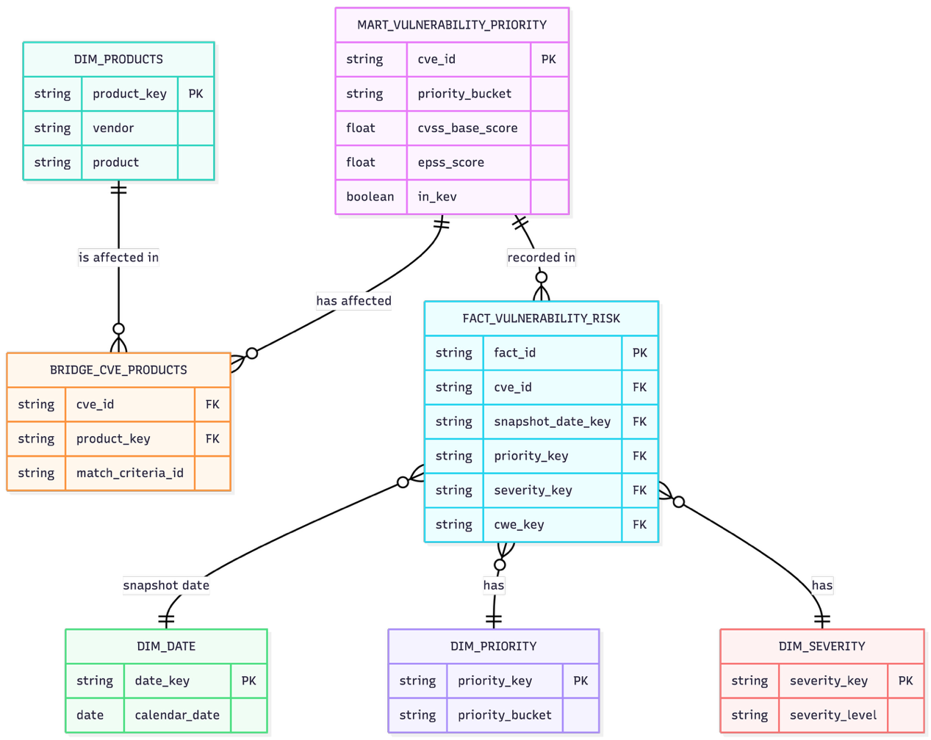
Figure 3.2: Entity Relationship Diagram (ERD)

4. Analytical Findings and Business-Relevant Interpretation
This section evaluates whether the engineered data outputs generate meaningful analytical insights for vulnerability prioritization by examining risk distributions, temporal dynamics, exploitation signals, and vendor or CWE concentration patterns.

4.1 Distribution-Level Risk Structure
The current run contains 5,133 records with a clear severity profile, showing an interpretable risk structure rather than a flat CVE list. Figure 4 shows MEDIUM as the largest class (2,099, 40.89%), followed by HIGH (1,583, 30.84%), CRITICAL (459, 8.94%), LOW (211, 4.11%), and NONE (7, 0.14%). Unknown severity remains substantial at 774 records (15.08%), so uncertainty must remain visible in reporting.
Figure 5 shows a similarly structured priority distribution: medium 2,097 (40.85%), high 1,573 (30.64%), low 992 (19.33%), and critical 471 (9.18%). This is not a simple copy of severity labels. All CVSS CRITICAL records remain critical priority, and 12 non-critical CVSS records are escalated into critical by enrichment signals. That behavior shows the model is using composite risk evidence rather than re-labeling one field.
One caveat is the treatment of unknown severity. All unknown-severity records currently fall into low priority because CVSS evidence is absent. That is conservative, but it can hide potential urgency inside the low queue. The unknown-rate should therefore be shown alongside priority shares in decision views.
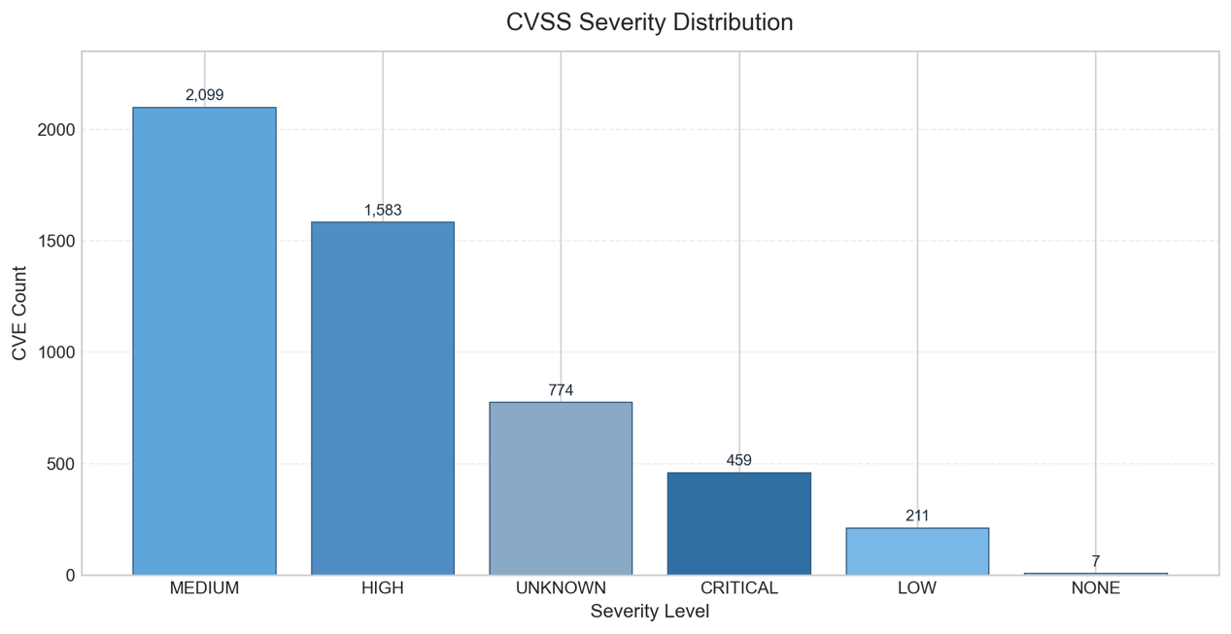
Figure 5. CVSS severity distribution from curated summary mart
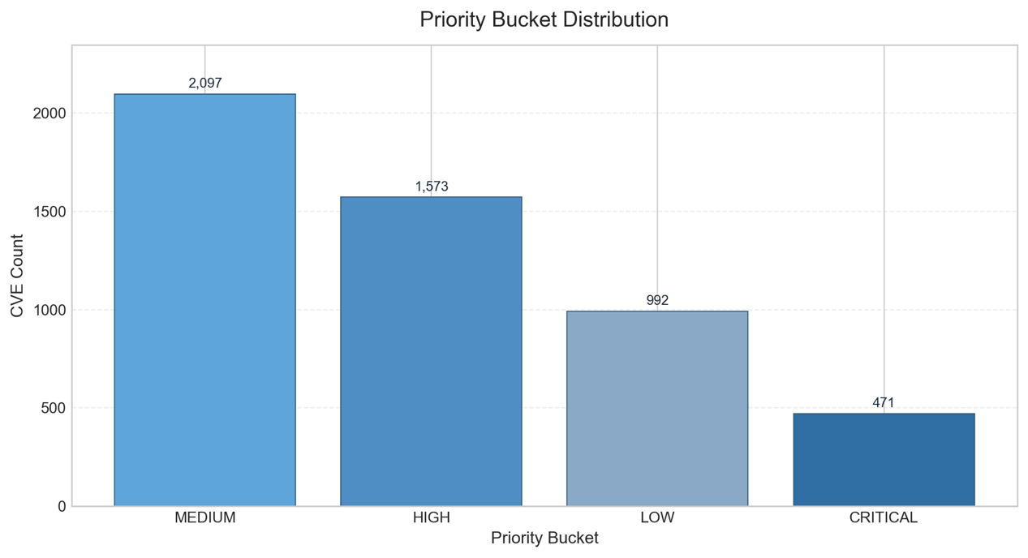
Figure 5. Priority Bucket Distribution

4.2 Time Dynamics and Freshness Signals
Temporal behavior confirms that vulnerability inflow is uneven. Across 59 observed publication days from 1 January to 28 February 2026, monthly volume rose from 1,963 to 3,170 CVEs, a 61.49% increase. Daily issuance is volatile: mean 87, median 67, minimum 2, and maximum 269.
Bursts are concentrated rather than random. The largest peak is 269 on 19 February, with additional high days at 207 (13 January and 10 February) and 206 (25 February). This pattern supports a practical operating conclusion: refresh schedules and downstream triage capacity should be designed for burst periods, not average days.
Records also continue to move after publication. The average publication-to-last-modified lag is 5.66 days and the maximum is 53.84 days. This validates the need for repeated refresh and for time-based reporting structures that can explain revisions.
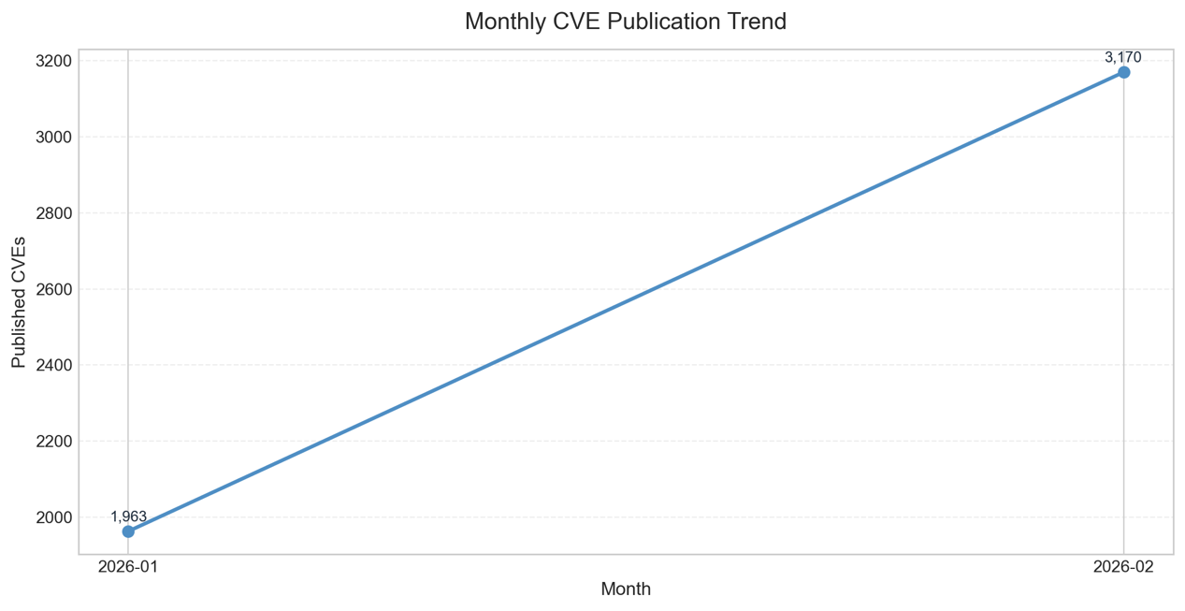
Figure 7. Monthly publication trends from fact and date dimensions

4.3 Exploitation Signals and Their Limits
KEV and EPSS enrich the model in complementary ways. KEV has high specificity but low coverage in this snapshot: 20 of 5,133 records (0.39%) are KEV-positive. KEV concentration follows severity rank, with 1.7429% in CRITICAL, 0.6317% in HIGH, 0.0953% in MEDIUM, and none in LOW/NONE/UNKNOWN.
At priority level, KEV behavior is decisive: all 20 KEV-positive records are in the critical bucket. This gives a 4.25% KEV rate inside critical-priority records (20 of 471) and zero KEV hits in medium, high, and low buckets. The prioritization logic is therefore strongly aligned with confirmed exploitation evidence.
EPSS provides the broad probabilistic layer that KEV cannot provide by itself. EPSS scores are available for 4,897 records (95.40%), with 236 missing values. The high-risk tail is small but meaningful: 82 records above 0.01, 20 above 0.10, and 7 above 0.50. Several top-EPSS records are not in KEV, which is where probabilistic prioritization adds value.
KEV is strongest for immediate confirmed-action routing, while EPSS is strongest for ranking likely near-term risk across the wider population.

4.4 Vendor/CWE Patterns and Interpretation Discipline
Vendor, product, and CWE aggregates provide useful direction for investigation planning. In this run, the largest vendor counts include Microsoft (186), Mozilla (73), Tenda (70), Adobe (69), and Color (68). The most frequent weaknesses are CWE-79 (586), CWE-862 (327), and CWE-74 (237). These outputs provide a practical way to focus on analysis beyond headline severity.
However, apparent concentration should be interpreted carefully. Among records with known vendor labels, the top ten vendors represent 25.60% of rows, and the top twenty represent 35.72%, indicating a long-tail exposure pattern rather than single-vendor dominance.
The larger limitation is missingness. Vendor and product are missing in 2,188 rows each (42.63%), CWE is missing in 545 rows (10.62%), and CVSS severity is missing in 774 rows (15.08%). Unknown-severity records are fully aligned with missing vendor/product labels in this snapshot, showing that missingness is clustered, not random. Grouped findings are therefore analytically valuable, but they should be presented as observed-coverage patterns rather than complete population census.
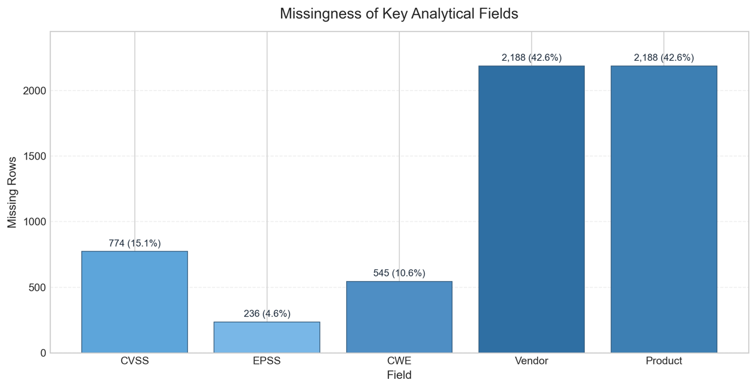
Figure 8. Missingness in key analytical fields, highlighting interpretation boundaries

5. Reproducibility, Collaboration Evidence, and Integrity Controls

5.1 Reproducibility Controls and Environment Friction
Reproducibility is supported by modular stage scripts, deterministic paths, and persisted outputs in data/curated/* and data/analytics.duckdb. Core transformation outputs remain stable across reruns, which makes independent verification practical.
Current friction is mostly environment-level. Parquet creation depends on pyarrow, but requirements.txt does not currently declare it, so clean environments may fail even when local machines succeed. Optional paths also have explicit prerequisites: Spark transformation requires MongoDB raw collections, and API execution requires full FastAPI runtime dependencies.
Execution logs show the same pattern. Core commands (build_vulnerability_mart, build_cve_product_bridge, build_star_schema, build_transformation_summaries, and load_duckdb) completed with return code 0. build_cvelist_enrichment also completes successfully in the current state, producing 336,658 summary rows, 2,012,447 reference rows, 348,357 problem-type rows, and 722,265 container rows while skipping two non-CVE JSON files. The remaining reproducibility caveat is environment consistency, not transformation logic failure.

5.2 Collaboration Evidence from Source Control
Collaboration evidence is taken from repository history and conference records. In the current snapshot, 32 commits across six contributor identities were shown, which indicates real multi-contributor development with a clear integration lead.
Commit timing also reflects staged construction: initial repository setup, late-February ingestion and schema work, then early-March transformation and dashboard integration. This sequence is consistent with iterative engineering rather than late single-pass assembly.
In addition to repository-based collaboration, the group held a series of scheduled meetings to coordinate development progress and task allocation. Formal group conferences took place on 23 February, 28 February, 4 March, 5 March, and 8 March. These meetings were used to review pipeline progress, discuss implementation challenges, allocate responsibilities across ingestion, transformation, analytics, and reporting components, and verify the outputs produced by each stage of the system. The meetings also served as checkpoints for validating script execution results and ensuring consistency between repository code, generated data artifacts, and the analytical findings included in the report.

5.3 Integrity Controls: What Is Claimed and What Is Not Claimed
This report uses strict claim boundaries. Success is stated only where commands completed and outputs are measurable. Failure is stated where failure was observed, with the original error context preserved. Unknowns are left as unknowns.
That discipline prevents overstatement. It separates validated technical success from remaining environment/process caveats and separates source-control evidence from broader team-process claims that need additional documentation.
Using this boundary model keeps interpretation reliable: every major statement can be traced to observable evidence, and remaining uncertainty is explicit instead of implied away.

Conclusion
In this project, we developed an end-to-end cyber-risk data pipeline by integrating four public vulnerability intelligence sources: NVD, CISA KEV, EPSS, and cvelistV5. The implementation demonstrates how heterogeneous feeds can be standardized and combined into a single analytical workflow for vulnerability prioritisation.
Raw snapshots were persisted in a layered storage design, with MongoDB used as the raw persistence store and CSV/Parquet outputs generated for curated analytical datasets. Transformation was implemented using a Spark/Python pipeline, and curated outputs were loaded into DuckDB for efficient query execution. A FastAPI serving layer and dashboard interface were then added for downstream consumption.
The project also applied reproducibility-oriented engineering practices through Git-based collaboration, scripted pipeline stages, Docker-based service support, and lightweight orchestration with Airflow. Overall, the solution delivers a practical and technically credible data engineering pipeline, while clearly documenting bounded limitations and operational trade-offs.

Reference List

Appendix

1. Team Composition
Member | Role focus in project | Primary deliverable areas
Diwen Cai | Ingestion and Source Pipeline | Source fetching scripts, ingestion parameterization, raw data refresh support
Zitong Ling | Storage and Schema Implementation | MongoDB raw loading, storage architecture, schema and table design support
Yuzhi Zhao | Transformation and Integration Coordination | Transformation scripts, integrated report drafting, result validation
Chien-Yu Lin | Data Integration and QA | Mapping rules, data dictionary/spec consistency, cross-stage quality checks
Puxin Wang | Analytics and Serving Layer | DuckDB query pack, API endpoint alignment, dashboard data interface support

2. Task Allocation Record
Work package | Owner | Supporting members | Main output artifacts
Source ingestion | Diwen Cai | Zitong Ling, Chien-Yu Lin | src/ingestion/*; data/raw/*
Raw storage and replay | Puxin Wang | Diwen Cai | src/storage/mongodb/load_raw_snapshots.py; docs/storage_architecture.md
Transformation (PySpark + Python ETL) | Zitong Ling | Chien-Yu Lin | src/transformation/*; docs/transformation_outputs.md
Data integration and schema governance | Chien-Yu Lin | Puxin Wang | docs/schema_mapping.md; docs/master_table_spec.md; docs/data_dictionary.md
Analytics, API, dashboard linkage | Yuzhi Zhao | Zitong Ling | sql/duckdb/queries.sql; src/api/fastapi_duckdb.py; dashboard/*
Documentation integration and final packaging | Zitong Ling | All members | README.md; docs/MSIN0166_Group_Report

3. Team Meeting Minutes
Meeting Date | Attendance | Agenda and Decisions | Review of Completed Work
2026-02-23 | Chien-Yu Lin,  Diwen Cai, Puxin Wang, Yuzhi Zhao,  Zitong Ling, | Confirmed cyber-risk project scope; selected NVD + KEV + EPSS as core sources; agreed layered architecture direction (raw/staging/curated). | Initial repository setup completed; baseline folder structure and task ownership confirmed.
2026-02-28 | Chien-Yu Lin,  Diwen Cai, Puxin Wang, Yuzhi Zhao,  Zitong Ling, | Reviewed schema definition progress; agreed canonical key cve_id; approved master-table-first integration path before star-schema extension. | Schema mapping/spec docs and storage documents completed; initial ingestion snapshots available.
2026-03-04 | Chien-Yu Lin,  Diwen Cai, Puxin Wang, Yuzhi Zhao,  Zitong Ling, | Reviewed transformed outputs and dashboard prototype; decided to keep dual path (PySpark architecture + Python ETL reproducibility path). | Curated datasets, star schema outputs, and dashboard prototype produced.
2026-03-05 | Chien-Yu Lin,  Diwen Cai, Puxin Wang, Yuzhi Zhao,  Zitong Ling, | Final technical review: query pack, API consistency, README alignment; agreed final evidence checklist for submission package. | Query pack and API alignment completed; repository reached integrated pipeline state for report finalization.
2026-03-08 | Chien-Yu Lin,  Diwen Cai, Puxin Wang, Yuzhi Zhao,  Zitong Ling, | Pre-submission quality review based on brief criteria; agreed to prioritise compliance artefacts (minutes, screenshots, access confirmation). | Final appendix package generated; remaining action is inserting final screenshots and access confirmation note.

4. Work Review and Quality Assurance Record
Review checkpoint | Reviewer(s) | What was checked | Outcome | Action taken
Mapping and schema consistency review | Chien-Yu Lin, Puxin Wang | Field naming consistency, key definitions, source-target mapping | Passed with minor naming cleanups | Updated mapping/spec docs and synchronised dictionary fields
Transformation output integrity review | Zitong Ling, Yuzhi Zhao | Row counts, duplicate key checks, output path consistency | Passed for core path; cvelist prerequisite missing in local run | Logged limitation transparently and retained rerun instructions
Query/API contract review | Yuzhi Zhao, Diwen Cai | SQL output compatibility with API fields and dashboard consumption | Passed | Standardised endpoint outputs to summary tables

5. Evidence Register
Evidence item | Current status | Repository/path evidence | Required before final submission
Source repository link | Complete | README + submission header | None
Raw source files | Complete (core three) | data/raw/nvd; data/raw/cisa_kev; data/raw/epss | Optional refresh snapshot
Curated outputs | Complete except cvelist in this run | data/curated/* | Run cvelist enrichment if required in final narrative
DuckDB artefact | Complete | data/analytics.duckdb | None
API endpoints | Implemented | src/api/fastapi_duckdb.py | Include runtime screenshot (/docs and /health)
Dashboard mode | Implemented | dashboard/ | Include API-mode screenshot
Spark execution proof | Not complete in local validation environment | PySpark script exists | Add one successful Spark run screenshot/log if environment permits
Team meeting minutes | Complete in this appendix | Appendix 3/4 | Add supporting screenshot/export if available
Teaching-team repository access proof | Pending explicit record | n/a | Add one-line access confirmation and screenshot if available

